Test Case: tc005_SPX_Dev5_Crear_Requisicion_Spot_Con_FAD_Tipo_Cobro_Project
Step 1 - Enter username and password and click to button Enter: Credentials Entered
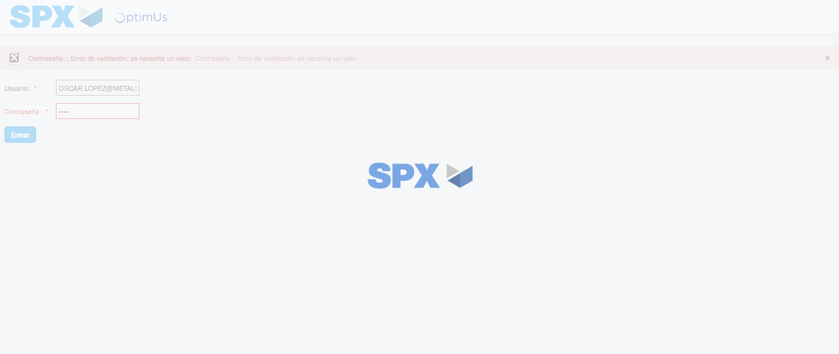Image file-name: QC_Testing-tc005_SPX_Dev5_Crear_Requisicion_Spot_Con_FAD_Tipo_Cobro_Project-1784573463294

Step 2 - Select to UEN and Access to Spot Buy Requisitions : UEN Correctly selected and Correct access
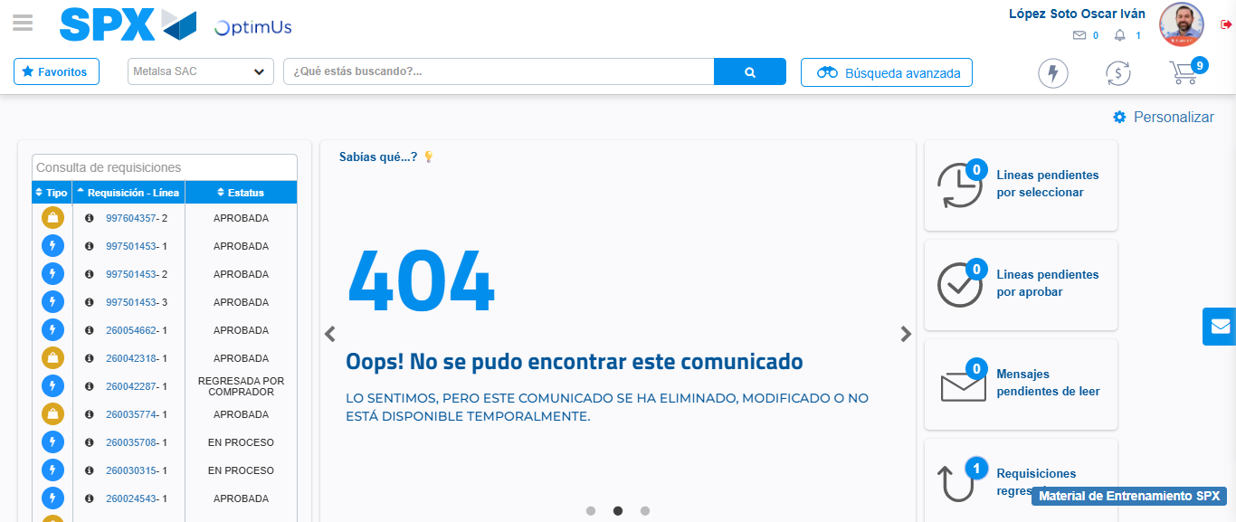Image file-name: QC_Testing-tc005_SPX_Dev5_Crear_Requisicion_Spot_Con_FAD_Tipo_Cobro_Project-1784573529025

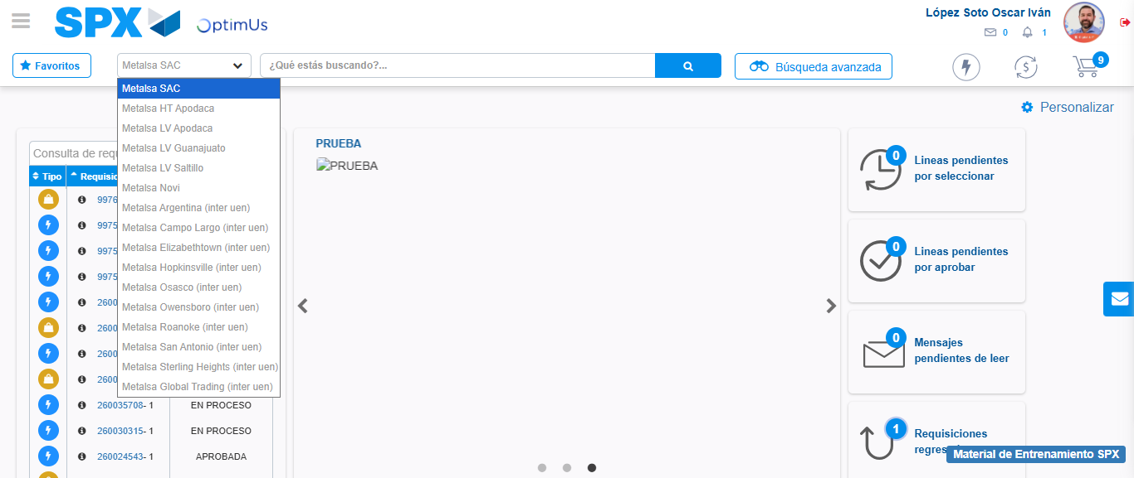Image file-name: QC_Testing-tc005_SPX_Dev5_Crear_Requisicion_Spot_Con_FAD_Tipo_Cobro_Project-1784573532042

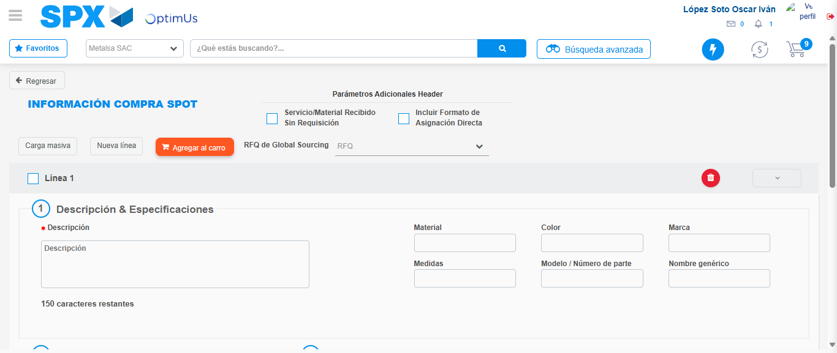Image file-name: QC_Testing-tc005_SPX_Dev5_Crear_Requisicion_Spot_Con_FAD_Tipo_Cobro_Project-1784573541866

Step 3 - Add FAD to Requisition: FAD Successfully Added
Image file-name: QC_Testing-tc005_SPX_Dev5_Crear_Requisicion_Spot_Con_FAD_Tipo_Cobro_Project-1784573542190

Image file-name: QC_Testing-tc005_SPX_Dev5_Crear_Requisicion_Spot_Con_FAD_Tipo_Cobro_Project-1784573542436

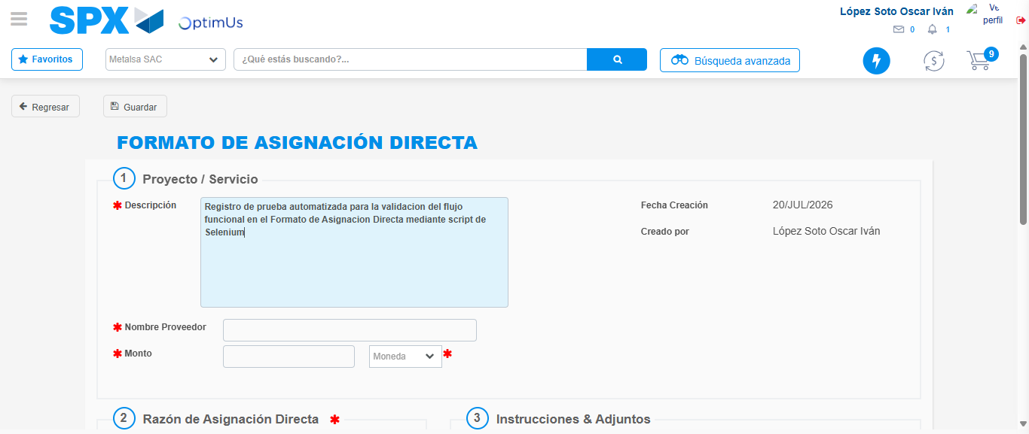Image file-name: QC_Testing-tc005_SPX_Dev5_Crear_Requisicion_Spot_Con_FAD_Tipo_Cobro_Project-1784573545436

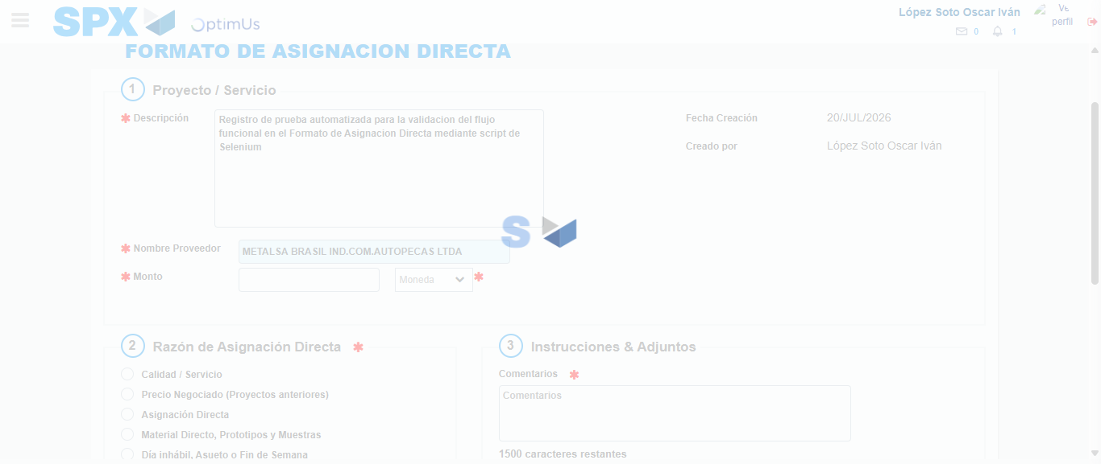Image file-name: QC_Testing-tc005_SPX_Dev5_Crear_Requisicion_Spot_Con_FAD_Tipo_Cobro_Project-1784573552356

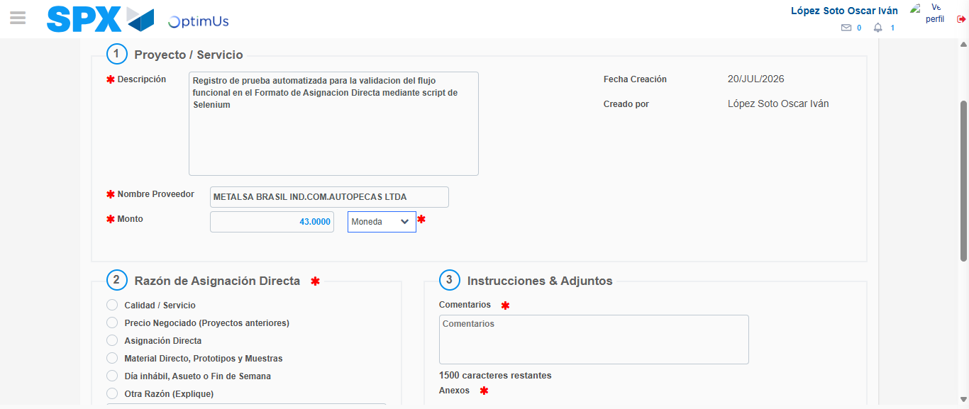Image file-name: QC_Testing-tc005_SPX_Dev5_Crear_Requisicion_Spot_Con_FAD_Tipo_Cobro_Project-1784573552924

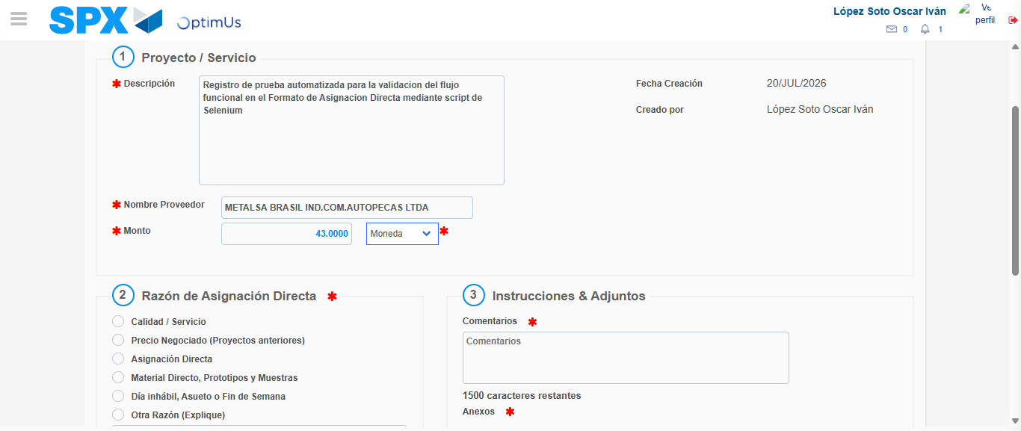Image file-name: QC_Testing-tc005_SPX_Dev5_Crear_Requisicion_Spot_Con_FAD_Tipo_Cobro_Project-1784573553157

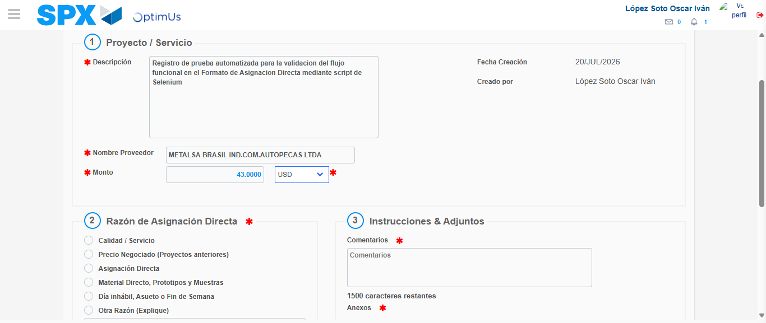Image file-name: QC_Testing-tc005_SPX_Dev5_Crear_Requisicion_Spot_Con_FAD_Tipo_Cobro_Project-1784573553609

Image file-name: QC_Testing-tc005_SPX_Dev5_Crear_Requisicion_Spot_Con_FAD_Tipo_Cobro_Project-1784573553831

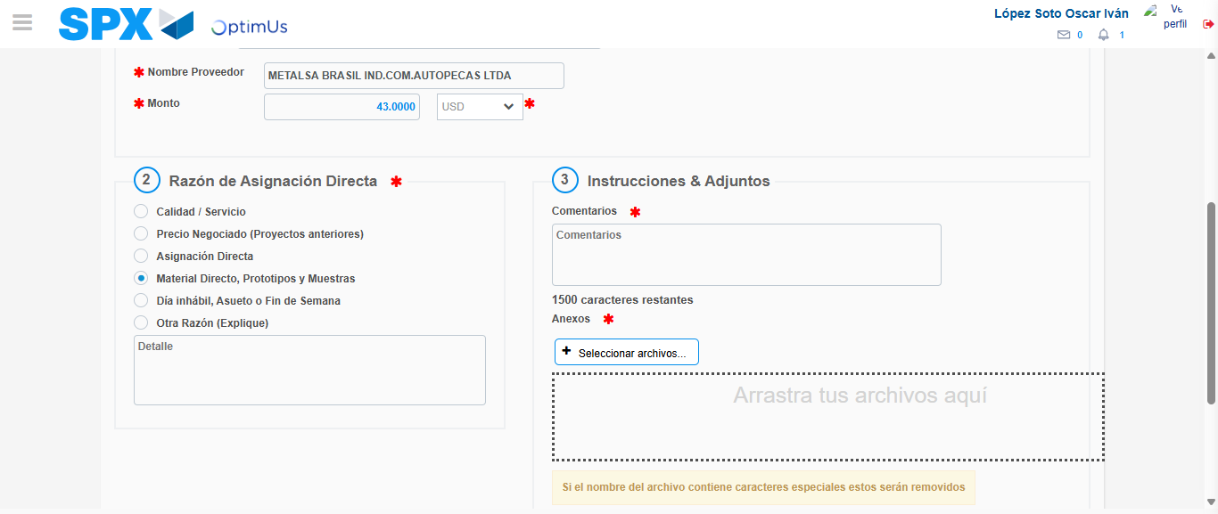Image file-name: QC_Testing-tc005_SPX_Dev5_Crear_Requisicion_Spot_Con_FAD_Tipo_Cobro_Project-1784573554820

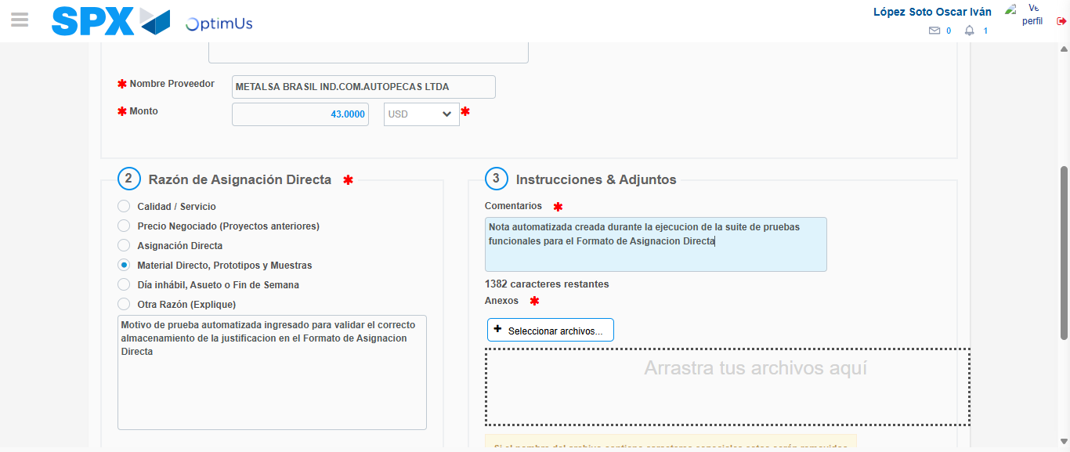Image file-name: QC_Testing-tc005_SPX_Dev5_Crear_Requisicion_Spot_Con_FAD_Tipo_Cobro_Project-1784573566298

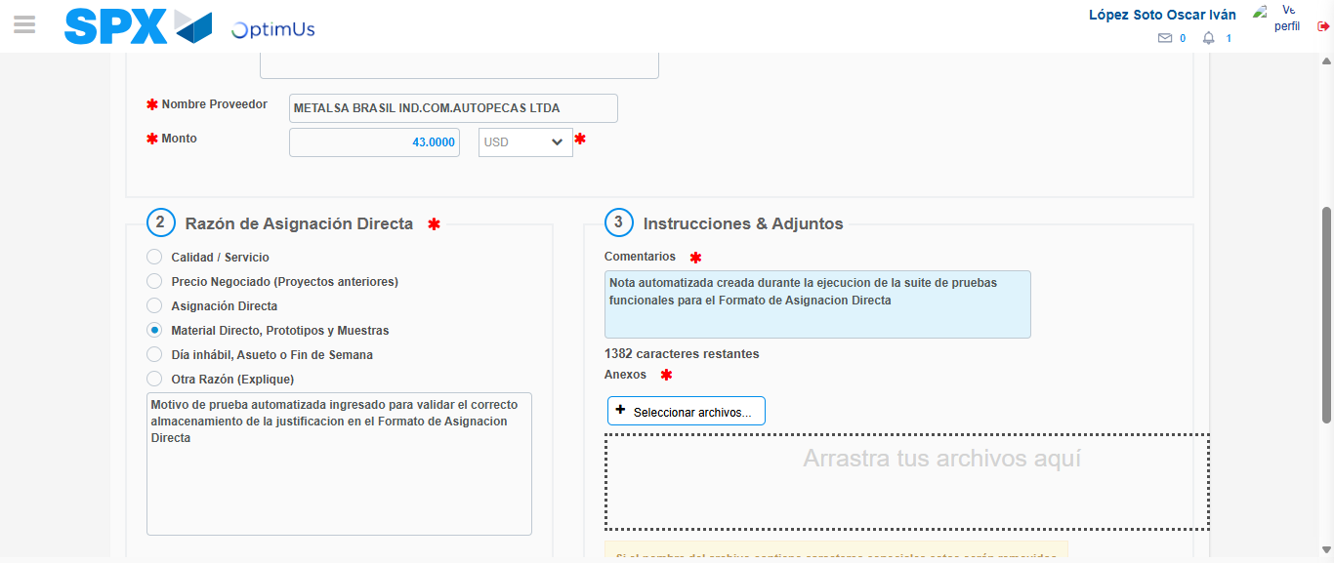Image file-name: QC_Testing-tc005_SPX_Dev5_Crear_Requisicion_Spot_Con_FAD_Tipo_Cobro_Project-1784573567199

Step 4 - Data Capture Spot Buy Requisition: Data captured correctly
Image file-name: QC_Testing-tc005_SPX_Dev5_Crear_Requisicion_Spot_Con_FAD_Tipo_Cobro_Project-1784573542190

Image file-name: QC_Testing-tc005_SPX_Dev5_Crear_Requisicion_Spot_Con_FAD_Tipo_Cobro_Project-1784573542436

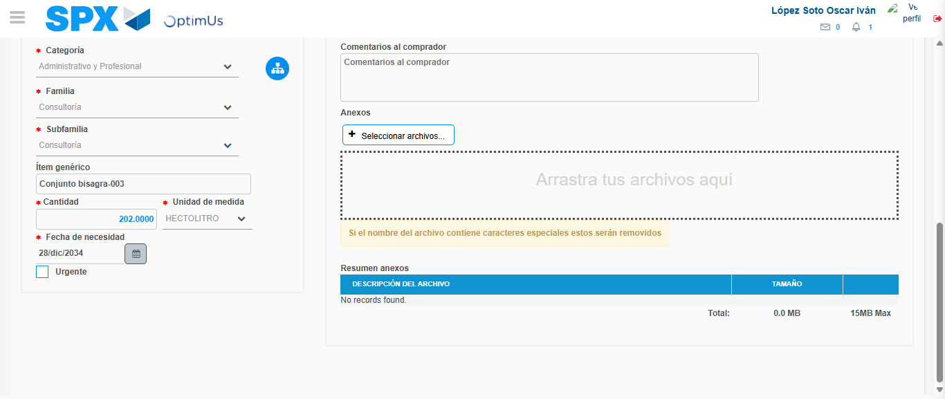Image file-name: QC_Testing-tc005_SPX_Dev5_Crear_Requisicion_Spot_Con_FAD_Tipo_Cobro_Project-1784573581357

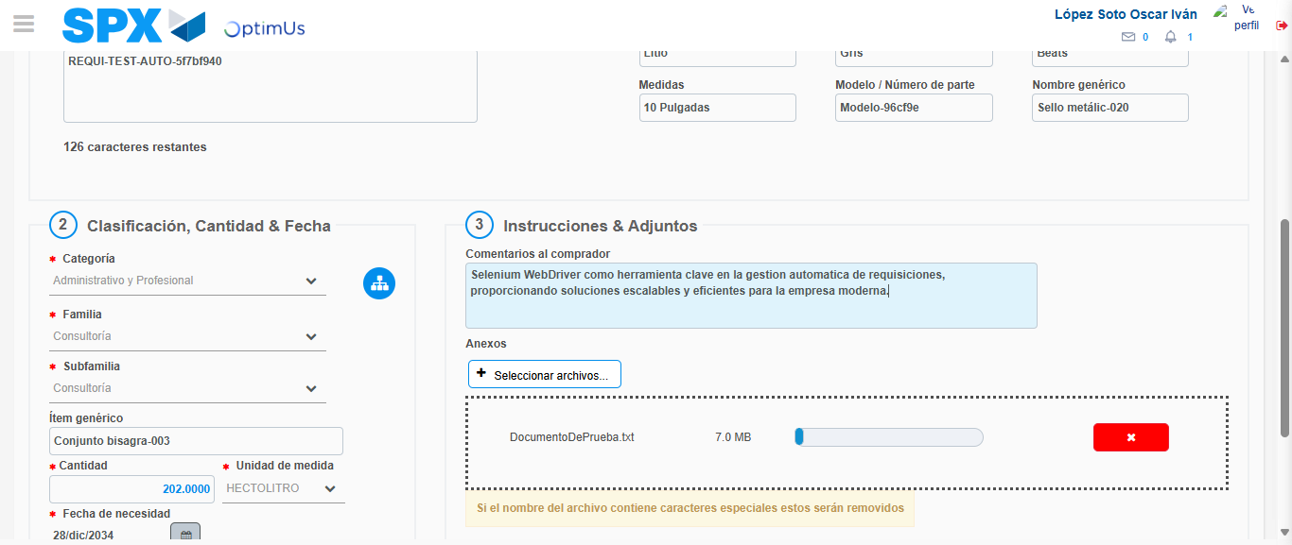Image file-name: QC_Testing-tc005_SPX_Dev5_Crear_Requisicion_Spot_Con_FAD_Tipo_Cobro_Project-1784573582306

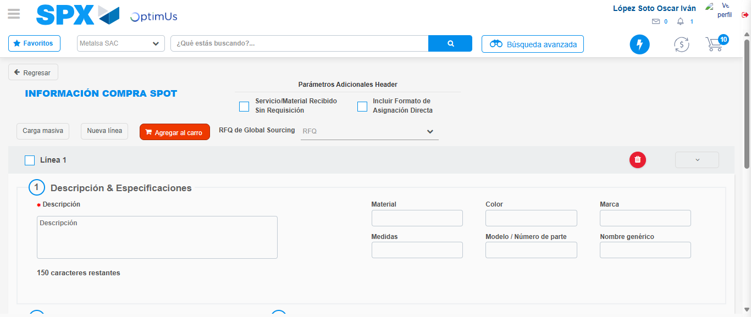Image file-name: QC_Testing-tc005_SPX_Dev5_Crear_Requisicion_Spot_Con_FAD_Tipo_Cobro_Project-1784573596357

Step 8 - Return to Main Page SPX : Return to Main Page SPX
Image file-name: QC_Testing-tc005_SPX_Dev5_Crear_Requisicion_Spot_Con_FAD_Tipo_Cobro_Project-1784573529025

Image file-name: QC_Testing-tc005_SPX_Dev5_Crear_Requisicion_Spot_Con_FAD_Tipo_Cobro_Project-1784573532042

Image file-name: QC_Testing-tc005_SPX_Dev5_Crear_Requisicion_Spot_Con_FAD_Tipo_Cobro_Project-1784573541866

Image file-name: QC_Testing-tc005_SPX_Dev5_Crear_Requisicion_Spot_Con_FAD_Tipo_Cobro_Project-1784573598637

Image file-name: QC_Testing-tc005_SPX_Dev5_Crear_Requisicion_Spot_Con_FAD_Tipo_Cobro_Project-1784573598830

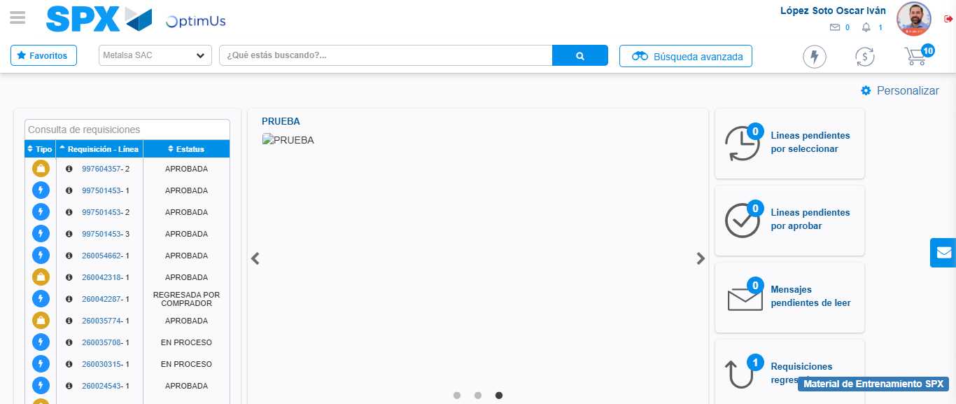Image file-name: QC_Testing-tc005_SPX_Dev5_Crear_Requisicion_Spot_Con_FAD_Tipo_Cobro_Project-1784573620097

Step 9 - Log Out : Log Out SPX
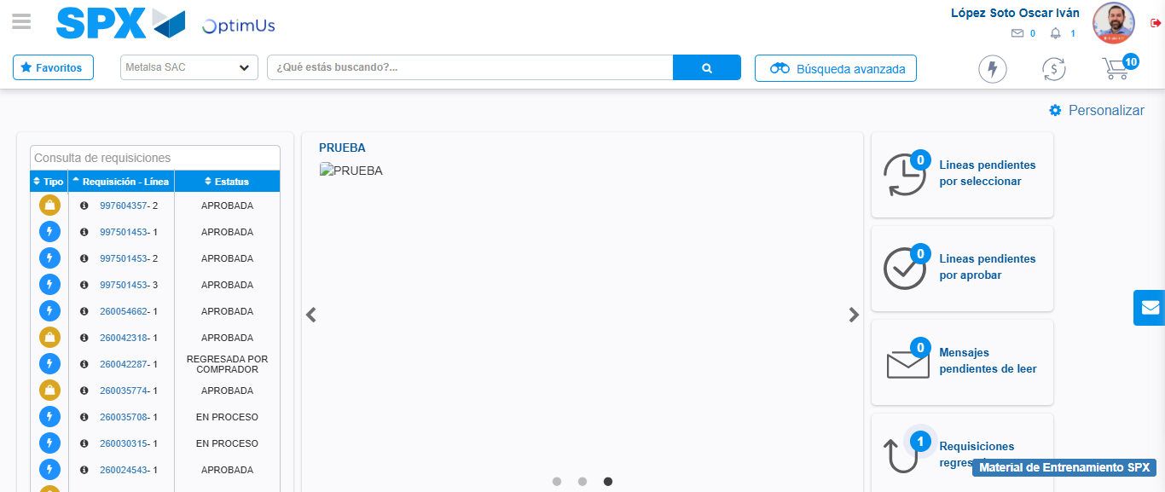Image file-name: QC_Testing-tc005_SPX_Dev5_Crear_Requisicion_Spot_Con_FAD_Tipo_Cobro_Project-1784573620443

